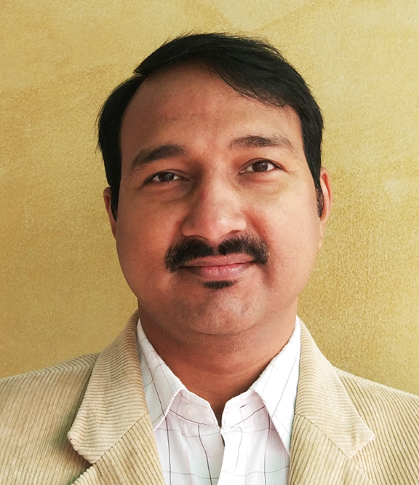
CREATIVE HEAD – DESIGN
BHAIRAV DUTT JOSHI

PROFILE

I have been instrumental in the growth of NetCarrots for last 17 years. Manage team of experts in art, graphic and web designs for last 8 years. Hands-on experience working with fortune 500 companies like Canon, Microsoft, Nokia, Trident, Delphi, Birla Cellulose, ACC, Grohe, MaxBupa and many more.

PORTFOLIO
https://bhairavjoshi.github.io
https://www.behance.net/bhairavjoshi

CONTACT
IIB/74A Sadhna, Vaishali
Ghaziabad - 201010
M: 87005 26750, 98103 04295|
E: bhairav.joshi@hotmail.com

PROFESSIONAL EDUCATION
IDF Certifications, 2018
Certificate Course in Computer (CIC) from IGNOU, 1999
Multimedia Animation, 1996
CABA Innovatives, School Lane, Bengali Market, New Delhi - 110 001
● 2D/3D Animation ● Morphing
● Sound Editing ● Titling
Computer Executive Course, 1993
C-SET (Center for Software Export & Training) Janpath, Connaught Place, New Delhi - 110 003

ACADEMIC
Graduate (B.A.) from Delhi University (Correspondence Course) in 1997.
Higher Secondary from Central Board of Secondary Education (C.B.S.E.) in 1992.

PERSONAL DETAIL
DOB - 20th August, 1972
Married with two children.
AREAS OF EXPERTISE & SKILLS

● Advertising ● Email Marketing ● Creative Direction
● Team Management ● Animation ● Web Designing
● SEO/SEM ● Wireframes ● Prototype
● User Centric Designs ● User Journey ● UI/UX

EXPERIENCE – Total 22 Years

Head Design at NetCarrots.com Pvt. Ltd.
Apr 2010 –Dec 2017
8 years
Develop and implement a cohesive design strategy for Company's global web sites (internal and external). Plan digital campaigns, oversee the creative process and guide team members. Working closely with account managers, designers, copywriters, HTML developers to provide creative support for engagement program and communication collateral for print & digital.
Job Responsibilities
● Understanding brief requirements, ideas generation, brainstorming
ideas with teams, all while keeping the budget constraints in mind.
● Designing campaigns and promotional strategies for our clients.
● Leading team of enthusiastic colleagues, and working for over 20
clients and numerous projects at any given time.
● Creating concepts and way-forward for the brand launches, and
following up with the progress throughout all phases of a project.
● Pitching for new clients and doing pro-active work for the existing
ones.
Sr. Visualizer at NetCarrots
Apr 2004 - Mar 2010
6 years
Creative conceptualization and execution includes websites, digital campaigns and print collaterals for various clients. Create overall user experience in discussion with clients.
Job Responsibilities
● Create concepts, execute designs, and maintain design concepts
through all phases of a project
● Create web site mockups
● Design Mailers & Greetings for online
Sr. Graphic Designer at NetCarrots
Aug 2000 - Mar 2004
4 years
Design websites with the overall user experience for various clients. Work closely with the web project managers to conceptualize interface designs, and with the technical team to integrate the design with the backend systems.
Job Responsibilities
● Designs static website mockups and maintain design concepts
through all phases of a project
● Design Mailers & Greetings for digital media
● Create Flyer, Banner, Leaflet etc. for offline
● Making still and animated banners
● Presentation using Flash
● Maintain text and graphics used on client sites
● Prepare, optimize and maintain visual assets like graphs etc.
● Test developed prototypes on various browsers, platforms, and
monitor configurations
Designer/ Animator at Cosmic Software
Created small animation clips for Maharishi Veda Vision Channel
● 2D & 3D Animation ● Presentation
● Web Publishing ● Print Publishing
Aug 1998 -
Mar 2000
2 years
Graphic Designer at Sunprints
Design various collaterals like brochure, pamphlets, training manuals etc. and packaging. Also did 3d modeling for some of products.
Aug 1996 -
April 1998
2 years

